**Program Name: 1. Simple Classes and Methods**

**Exercise:**

**Aim: i) Write a Program to Print “Hello Java”**

**Program:**

package javalab;

public class Javalab {

public static void main(String[] args)

{

System.out.println("Hello Java");

}

}

**Output:**

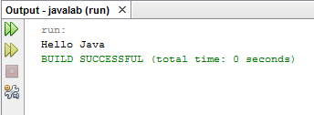

**Aim: ii) Write a Program to find the area of room using two classes**

**Program:**

package javalab;

import java.util.*;

class length

{

int l;

}

class breadth extends length

{

int b;

int area()

{

return(l*b);

}

}

public class Javalab

{

public static void main(String[] args)

{

breadth box= new breadth();

box.l=12;

box.b=5;

int a=box.area();

System.out.println("The area of the room is : "+a);

}

}

**Output:**

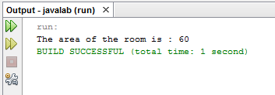

**Aim: iii) Write a Program to find the greatest of the following numbers 325,712,478**

**Program:**

package javalab;

import java.util.*;

public class Javalab

{

public static void main(String[] args)

{

int a=325;

int b=712;

int c=478;

if (a>b && a>c)

System.out.println("No. A is largest ");

else if(b>a && b>c)

System.out.println("No. B is largest ");

else if(c>a && c>b)

System.out.println("No. C is largest");

else

System.out.println("One or more number i same ");

}

}

**Output:**

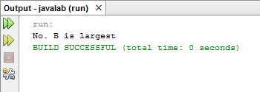

**Program Name: 2. Array Implementation**

**Exercise:**

**Aim: i) Write a program to tell that how many numbers are even or odd on the following: 50,65,56,71**

**Program:**

package javalab;

import java.util.*;

public class Javalab

{

public static void main(String[] args)

{

int a[]={50,65,56,71};

int even=0,odd=0;

for(int i=0;i<a.length;i++)

{

if(a[i]%2==0)

even++;

else

odd++;

}

System.out.println("The no.of even :"+even+" odd : "+odd);

System.out.println("Even Numbers :");

for(int i=0;i<a.length;i++)

{

if(a[i]%2==0)

{

System.out.println(a[i]);

}

}

System.out.println("Odd Numbers :");

for(int i=0;i<a.length;i++)

{

if(a[i]%2!=0)

{

System.out.println(a[i]);

}

}

}

}

**Output:**

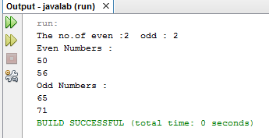

**Aim: ii) Write a program to sort the following number in ascending order**

**55,65,56,71,81**

**Program:**

package javalab;

import java.util.*;

public class Javalab

{

public static void main(String[] args)

{

int a[]={55,65,56,71,81};

int size=a.length;

for(int i=0;i<=size;i++)

{ for(int j=0;j<size-1;j++)

{

if(a[j+1]<a[j])

{ int temp=a[j];

a[j]=a[j+1];

a[j+1]=temp;

}

}

}

for(int i=0;i<a.length;i++)

{

System.out.println(a[i]);

}

}

}

**Output:**

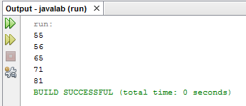

**Aim: ii) Write a program to print patter like this :**

**1**

**22**

**333**

**4444**

**55555**

**Program:**

package javalab;

import java.util.*;

public class Javalab

{

public static void main(String[] args)

{

for(int i=0;i<6;i++)

{

for(int j=0;j<i;j++)

{

System.out.print(i);

}

System.out.println("");

}

}

}

**Output:**

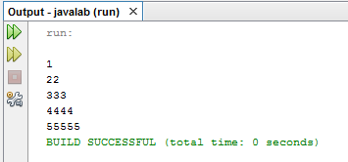

**Program Name: 3. Command Line Argument, String Implementation**

**Exercise:**

**Aim: i) Write a Program to implement Command Line Arguments**

**Program:**

public class Javalab {

public static void main(String[] args)

{

System.out.println("Enter the value");

int r=Integer.parseInt(args[0]);

System.out.println(r);

}

}

**Output:**

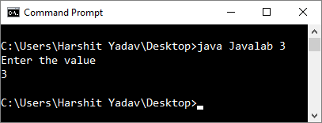

**Aim: ii) Write a Program to sort the following words in dictionary order [Madras, Delhi, Calcutta, Bombay, Ahmedabad]**

**Program:**

package javalab;

import java.util.*;

public class Javalab

{

public static void main(String[] args)

{

String arr[]={"Madras", "Delhi", "Ahmadabad", "Calcutta", "Bombay"};

String temp;

for(int i=0;i<arr.length;i++)

{ temp=arr[i];

for(int j=0;j<arr.length;j++)

{

if (i==j) continue;

int x=temp.compareTo(arr[j]);

if(x<0)

{ temp=arr[j];

arr[j]=arr[i];

arr[i]=temp;

}

}

}

for(int i=0;i<arr.length;i++)

{

System.out.println(arr[i]);

}

}

}

**Output:**

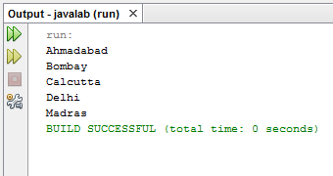

**Program Name: 4. Implementation of Construction, Method Overloading, Overriding, Nesting.**

**Exercise:**

**Aim: i) Write a program to find the area of room using constructor.**

**Source code:**

package javalab;

class Harshit

{

int length,breadth;

Harshit(int x, int y)

{

length=x;

breadth=y;

}

int roomarea()

{

return(length*breadth);

}

}

public class Javalab

{

public static void main(String[] args)

{ Harshit a=new Harshit(18,15);

int temp=a.roomarea();

System.out.println("Area of room is " +temp+ " Sq ft");

}

}

**Output:**

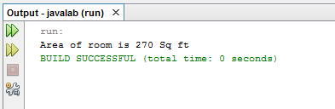

**Aim: ii) Write a program to implement method overloading.**

**Source code:**

package labfile;

public class methdoverload{

static int length,breadth,height;

static float r;

void area(int l,int b, int h,float r)

{

length=l;

breadth=b;

height=h;

this.r=r;

System.out.println("Length: " +length+ "\nWidth: " +breadth+ "\nHeight: "+height+ "\nRadius: "+r);

}

void area(int l,int b)

{

System.out.println("Perimeter of Rectangle: " +(2*(l+b)));

}

void area(int l,int b, int h)

{

System.out.println("Perimeter of Triangle: " +(l+b+h));

}

void area(float r)

{

System.out.println("Perimeter of Circle: " +(2*3.14*r));

}

}

public class MethodOverload {

public static void main(String[] args) {

methdoverload obj=new methdoverload();

obj.area(10,6,8, (float) 4.0);

obj.area(methdoverload.length,methdoverload.breadth);

obj.area(methdoverload.length,methdoverload.breadth,methdoverload.height);

obj.area(methdoverload.r);

}

}

**Output:**

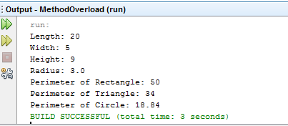

**Aim: iii) Write a program to implement static keyword.**

**Source code:**

package labfile;

public class methdoverload{

static int length,breadth,height;

static float r;

void area(int l,int b, int h,float r)

{

length=l;

breadth=b;

height=h;

this.r=r;

System.out.println("Length: " +length+ "\nWidth: " +breadth+ "\nHeight: "+height+ "\nRadius: "+r);

}

void area(int l,int b)

{

System.out.println("Perimeter of Rectangle: " +(2*(l+b)));

}

}

public class MethodOverload {

public static void main(String[] args) {

methdoverload obj=new methdoverload();

obj.area(10,6,8, (float) 4.0);

obj.area(methdoverload.length,methdoverload.breadth);

}

}

**Output:**

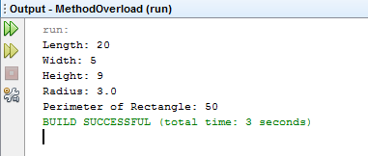

**Aim: iv) Write a program to implement nesting of method.**

**Source code:**

package mnesting;

public class MNesting {

int l,w;

MNesting(int a, int b){

l=a;

w=b;

System.out.println("Length:" +l);

System.out.println("Width:" +w);

}

int area() {

int ar=l*w;

return(ar);

}

void display(){

int result=area();

System.out.println("Area: " +area()+" Sq ft");

}

public static void main(String[] args) {

MNesting obj=new MNesting(35,40);

obj.display();

}

}

**Output:**

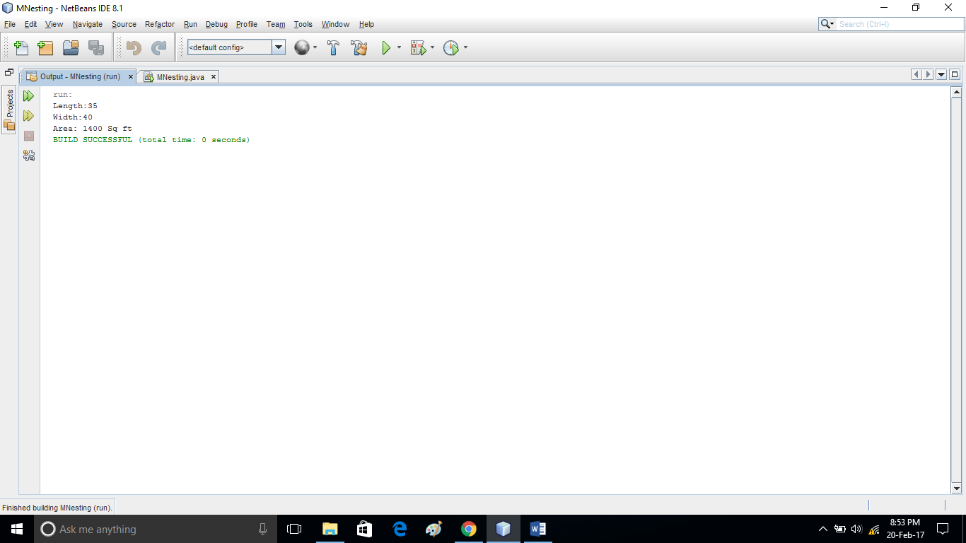

**Aim: v) Write a program to implement overriding of method.**

**Source code:**

package moverride;

class sun1{

int x, y;

One(int a,int b){

x=a;

y=b;

}

void display(){

System.out.println("Value of x: " +x+"\nValue of y: "+y);

}

}

class Sun2 extends Sun1{

int r;

Two(int a,int b){

super(a,b);

r=(a+b);

}

void display(){

super.display();

System.out.println("Sum: " +r);

}

}

public class MethodOverload {

public static void main(String[] args) {

Sun2 obj=new Sun2(200,567);

obj.display();

}

}

**Output:**

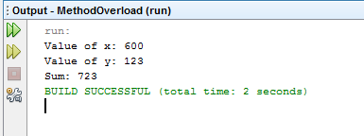

**Program Name: 5. Implementation of Inheritance**

**Exercise:**

**Aim: i) Write a program to implement single inheritance and multiple inheritance (being implemented with the help of interface).**

**Source code:**

package inheritance;

class Parent

{

static int count;

int eng,physics;

Parent(int x,int y)

{

eng=x;

physics=y;

}

}

class child extends Parent

{

int maths,history;

float avg;

child(int x,int y,int c,int d)

{

super(x,y);

maths=c;

history=d;

avg=(eng+physics+maths+history)/4;

count++;

System.out.println("The avg of 4 subjects is->"+avg);

}

}

interface sports

{

int physical=30;

void calculate();

int sum(int x,int y);

int sum(int x,int y,int c,int d);

}

class summary extends child implements sports

{

float total;

summary(int x,int y,int d,int e)

{

super(x,y,d,e);

}

public void calculate()

{

total=(avg+physical)/2;

count++;

System.out.println("The total avg of all subjects"+total);

}

public int sum(int x,int y)

{

return x+y;

}

public int sum(int x,int y,int c,int d)

{

return x+y+c+d;

}

}

public class Inheritance {

public static void main(String[] args) {

summary s= new summary(30,40,50,20);

s.calculate();

int catch1=s.sum(30, 40);

int catch2=s.sum(30,40,50,20);

System.out.println("The no of times avg is calculated"+summary.count);

System.out.println("The sum is"+catch1);

System.out.println("The sum is"+catch2);

}

}

**Output:**

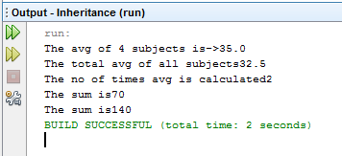

**Aim: iii) Write a program to implement package.**

**Source code:**

**File 1:**

package Test;

public class Demo1

{

public void display()

{

System.out.println("hello");

}

}

**File 2:**

package Test;

public class Demo2

{

public void show()

{

System.out.println("Demo2");

}

}

**File 3:**

import Test.*;

public class Main

{

public static void main(String args[])

{

Demo1 d1=new Demo1();

d1.display();

Demo2 d2=new Demo2();

d2.show();

}

}

**Output:**

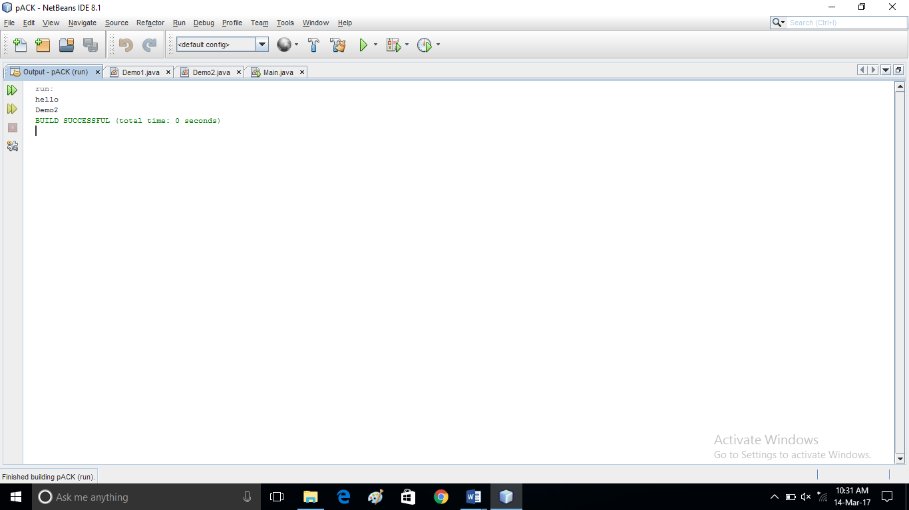

**Program Name: 6. Multithreading, Exception Handling, Applet Programming.**

**Exercise:**

**Aim: i) Write a program using the function system function yield(), stop(), sleep().**

**Source code:**

package javaapplication23;

class Test extends Thread{

public void run(){

System.out.println("First Thread started...");

try{

for(int i=1;i<3;i++){

Thread.sleep(1000); // 1 second

System.out.println("First Thread is Running... "+i);

}

System.out.println("First Thread completed...");

}

catch(Exception e){}

}

}

public class JavaApplication23 {

public static void main(String[] args) throws Exception{

System.out.println("Main Thread started...");

Test t = new Test();

t.start();

for(int i=3;i>1;i--){

Thread.sleep(1000);

System.out.println("Main Thread is Running... "+i);

if(i==2){

t.join();

}

}

System.out.println("Main Thread completed...");

}

}

**Output:**

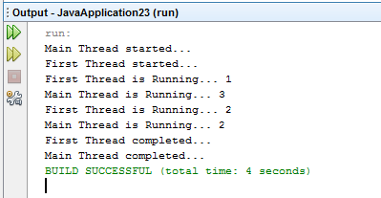

**Aim: ii) Write a program to implement multiple try catch block.**

**Source code:**

package javaapplication24;

public class JavaApplication24 {

public static void main(String[] args) {

try{

System.out.println("first try block");

int x=10/0;

System.out.println("first try block end");

}

catch(ArithmeticException e){

try{

System.out.println("second try block");

String s =null;

System.out.println(s.equals("second try block end"));

}

catch(NullPointerException n)

{

System.out.println(n);

}

System.out.println("Number cannot be divide by zero");

}

System.out.println("End of Main");

}

}

**Output:**

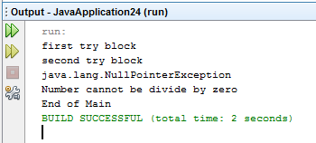

**Aim: iii) Write a program to print “Hello Java” using applet programming.**

**Source code:**

import java.applet.Applet;

import java.awt.*;

public class NewApplet extends Applet {

public void init() {

Frame f= new Frame();

List l1=new List(5);

l1.setBounds(100,100, 75,75);

l1.add("Item 1");

l1.add("Item 2");

l1.add("Item 3");

l1.add("Item 4");

l1.add("Item 5");

f.add(l1);

f.setSize(400,400);

f.setLayout(null);

f.setVisible(true);

f.setTitle("My Applet");

}

}

**Output:**

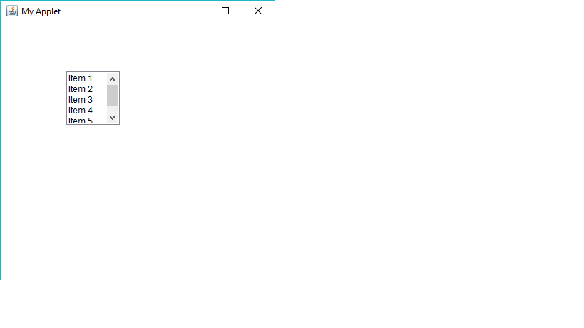

**Program Name: 7. File Handling, Java Networking**

**Exercise 7:**

**Aim: i) Write a Program to copy the content of one file to another file using Character Stream Class.**

**Source Code:**

package exp4;

import java.io.*;

public class cstream

{

public static void main(String args[])

{

File fin=new File("C:\\Users\\DELL\\Desktop\\input.txt");

File fout=new File("C:\\Users\\DELL\\Desktop\\output.txt");

FileReader ins=null;

FileWriter ons=null;

try

{

ins=new FileReader(fin);

ons=new FileWriter(fout);

int ch;

while((ch=ins.read())!=-1)

{

ons.write(ch);

}

ins.close();

ons.close();

}

catch(IOException e)

{

System.out.println("catch block executed");

}

}

}

**Output:**

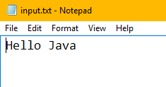

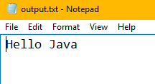

**Aim: ii) Write a Program to copy the content of one file to another file using Byte Stream Class.**

**Source Code:**

package exp4;

import java.io.*;

public class bstream

{

public static void main(String args[])

{

FileInputStream infile=null;

FileOutputStream outfile=null;

try

{

byte byteread=0;

infile=new FileInputStream("C:\\Users\\DELL\\Desktop\\input1.txt");

outfile=new FileOutputStream("C:\\Users\\DELL\\Desktop\\output1.txt");

while(byteread!=-1)

{

byteread=(byte)infile.read();

outfile.write(byteread);

}

infile.close();

outfile.close();

}

catch(IOException e)

{

System.out.println("catch block executed");

}

}

}

**Output:**

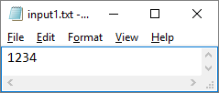

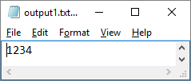

**Aim: iii) Write a Program to find the IP address of a local machine.**

**Source Code:**

package exp4;

import java.net.*;

public class ipaddlocal

{

public static void main(String[] args) throws Exception

{

try

{

InetAddress addr = InetAddress.getLocalHost();

System.out.println("Local HostAddress: "+addr.getHostAddress());

String hostname = addr.getHostName();

System.out.println("Local host name: "+hostname);

}

catch(UnknownHostException e)

{

System.out.println("exception occured");

}

}

}

**Output:**

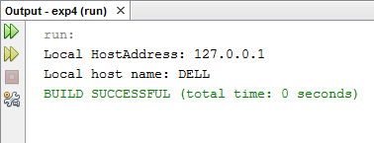

**Aim: iv) Write a Program to find the IP address of a remote machine.**

**Source Code:**

package exp4;

import java.net.*;

class ip_remote

{

public static void main(String args[])

{

try

{

InetAddress address[] = InetAddress.getAllByName("DELL");

for(int i=0;i<address.length;i++)

{

System.out.println("The IP Address of Remote machine is: "+ address[i]);

}

}

catch(UnknownHostException e)

{

System.out.println("Unknown Host Exception");

}

}

}

**Output:**

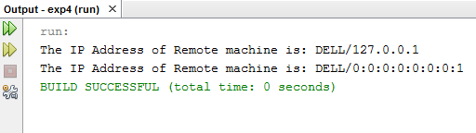

**Program Name: 8. AWT, Swings, Collection**

**Exercise 8:**

**Aim: i) Write a Program to implement calculator in AWT.**

**Source Code:**

package exp3;

import java.awt.*;

public class calculator2

{

String s1,s2,s3,s4,s5;

Frame f;

Button b1,b2,b3,b4,b5,b6,b7,b8,b9,b10,b11,b12,b13,b14,b15,b16,b17;

Panel p;

TextField tf;

calculator2()

{

f = new Frame("My calculator");

p = new Panel();

f.setLayout(new FlowLayout());

b1 = new Button("0");

b2 = new Button("1");

b3 = new Button("2");

b4 = new Button("3");

b5 = new Button("4");

b6 = new Button("5");

b7 = new Button("6");

b8 = new Button("7");

b9 = new Button("8");

b10 = new Button("9");

b11 = new Button("+");

b12 = new Button("-");

b13 = new Button("*");

b14 = new Button("/");

b15 = new Button("%");

b16 = new Button("=");

b17 = new Button("C");

tf = new TextField(20);

f.add(tf);

p.setLayout(new GridLayout(4,4,10,10));

p.add(b1);p.add(b2);p.add(b3);p.add(b4);p.add(b5);p.add(b6);p.add(b7);p.add(b8);p.add(b9);

p.add(b10);p.add(b11);p.add(b12);p.add(b13);p.add(b14);p.add(b15);p.add(b16);p.add(b17);

f.add(p);

f.setSize(300,300);

f.setVisible(true);

}

public static void main(String[] abc)

{

calculator2 v = new calculator2();

}

}

**Output:**

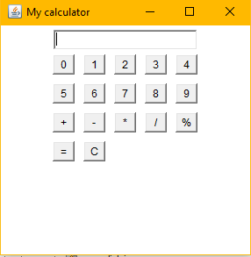

**Aim: ii) Write a Program to implement the following in swings:**

* **JTextField and JPasswordField**

**Source Code:**

package exp3;

import javax.swing.*;

import java.awt.*;

class loginframe extends JFrame

{

Container c;

Font f1=new Font("Arial",Font.BOLD,20);

JLabel l1=new JLabel("Username");

JLabel l2=new JLabel("Password");

JTextField t1=new JTextField();

JPasswordField pass=new JPasswordField();

JButton b1=new JButton("LOGIN");

loginframe()

{

c=this.getContentPane();

c.setBackground(Color.RED);

c.setLayout(null);

l1.setFont(f1);

l2.setFont(f1);

t1.setFont(f1);

pass.setFont(f1);

b1.setFont(f1);

l1.setBackground(Color.RED);

l1.setForeground(Color.YELLOW);

l2.setBackground(Color.RED);

l2.setForeground(Color.YELLOW);

l1.setBounds(150,50,100,40);

l2.setBounds(150,150,100,40);

t1.setBounds(300,50,200,40);

pass.setBounds(300,150,200,40);

b1.setBounds(260,260,100,40);

c.add(l1);

c.add(l2);

c.add(t1);

c.add(pass);

c.add(b1);

}

}

public class loginform

{

public static void main(String args[])

{

loginframe f=new loginframe();

f.setTitle("Login Form");

f.setVisible(true);

f.setDefaultCloseOperation(3);

f.setBounds(250,100,700,500);

}

}

**Output:**

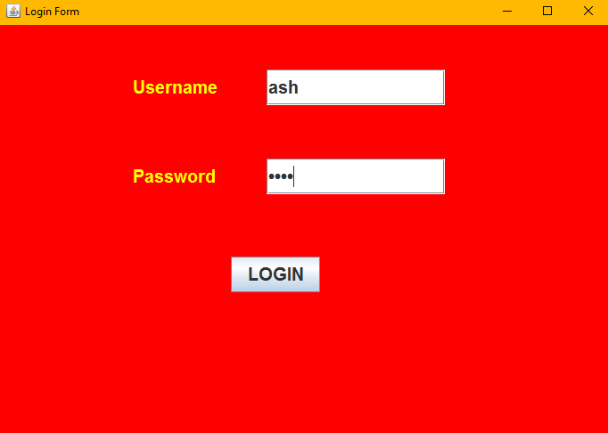

* **JTable**

**Source Code:**

package exp3;

import javax.swing.*;

public class swingtable

{

JFrame f;

swingtable()

{

f=new JFrame("JTable");

String data[][]={{"101","Ash","CSE"},{"102","Richie","EE"}};

String column[]={"ID","NAME","BRANCH"};

JTable jt=new JTable(data,column);

jt.setBounds(30,40,200,300);

JScrollPane sp=new JScrollPane(jt);

f.add(sp);

f.setBounds(10,10,300,200);

f.setDefaultCloseOperation(3);

f.setVisible(true);

}

public static void main(String args[])

{

swingtable s=new swingtable();

}

}

**Output:**

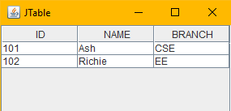

* **JComboBox**

**Source Code:**

package exp3;

import javax.swing.*;

public class scomponent1

{

JFrame f;

scomponent1()

{

f=new JFrame("ComboBox Example");

String branch[]={"CSE","EE","ME","CE"};

JComboBox cb=new JComboBox(branch);

cb.setBounds(50,50,90,20);

f.add(cb);

f.setLayout(null);

f.setSize(400,500);

f.setDefaultCloseOperation(3);

f.setVisible(true);

}

public static void main(String args[])

{

scomponent1 s=new scomponent1();

}

}

**Output:**

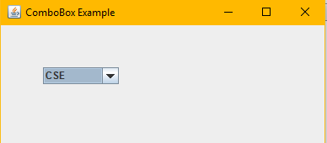

* **JProgressBar**

**Source Code:**

package exp3;

import java.awt.*;

import javax.swing.*;

public class progressbar1

{

public static void main(String args[]) throws Exception

{

JFrame f=new JFrame("Progress Bar");

Container c=f.getContentPane();

f.setSize(400,80);

f.setLayout(new FlowLayout());

JProgressBar pb=new JProgressBar(0,100);

pb.setStringPainted(true);

c.add(pb);

f.setVisible(true);

f.setDefaultCloseOperation(3);

for(int i=0;i<=100;i++)

{

pb.setValue(i);

Thread.sleep(100);

}

}}

**Output:**

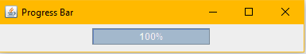

* **JList**

**Source Code:**

package exp3;

import javax.swing.*;

public class jlist

{

jlist()

{

JFrame f=new JFrame();

DefaultListModel l1=new DefaultListModel();

l1.addElement("C");

l1.addElement("C++");

l1.addElement("Java");

l1.addElement("C#");

JList list=new JList(l1);

list.setBounds(100,100,75,75);

f.add(list);

f.setSize(400,400);

f.setLayout(null);

f.setVisible(true);

f.setDefaultCloseOperation(3);

}

public static void main(String args[])

{

jlist list1=new jlist();

}

}

**Output:**

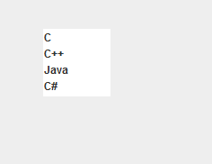

* **JTree**

**Source Code:**

package exp3;

import javax.swing.*;

import javax.swing.tree.DefaultMutableTreeNode;

public class jtree

{

JFrame f;

jtree()

{

f=new JFrame();

DefaultMutableTreeNode style=new DefaultMutableTreeNode("Style");

DefaultMutableTreeNode color=new DefaultMutableTreeNode("Color");

DefaultMutableTreeNode font=new DefaultMutableTreeNode("Font");

style.add(color);

style.add(font);

DefaultMutableTreeNode red=new DefaultMutableTreeNode("Red");

DefaultMutableTreeNode blue=new DefaultMutableTreeNode("Blue");

DefaultMutableTreeNode green=new DefaultMutableTreeNode("Green");

DefaultMutableTreeNode yellow=new DefaultMutableTreeNode("Yellow");

color.add(red);

color.add(blue);

color.add(green);

color.add(yellow);

JTree jt=new JTree(style);

f.add(jt);

f.setSize(200,200);

f.setVisible(true);

f.setDefaultCloseOperation(3);

}

public static void main(String args[])

{

jtree j1=new jtree();

}

}

**Output:**

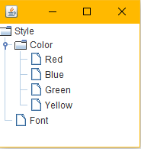

* **JColorChooser**

**Source Code:**

package exp3;

import java.awt.*;

import java.awt.event.*;

import javax.swing.*;

public class ColorChooser extends JFrame implements ActionListener

{

JButton b;

Container c;

ColorChooser()

{

c=getContentPane();

c.setLayout(new FlowLayout());

b=new JButton("color");

b.addActionListener(this);

c.add(b);

}

public void actionPerformed(ActionEvent e)

{

Color initialcolor=Color.RED;

Color color=JColorChooser.showDialog(this,"Select a color",initialcolor);

c.setBackground(color);

}

public static void main(String args[])

{

ColorChooser ch=new ColorChooser();

ch.setSize(400,400);

ch.setVisible(true);

ch.setDefaultCloseOperation(3);

}

}

**Output:**

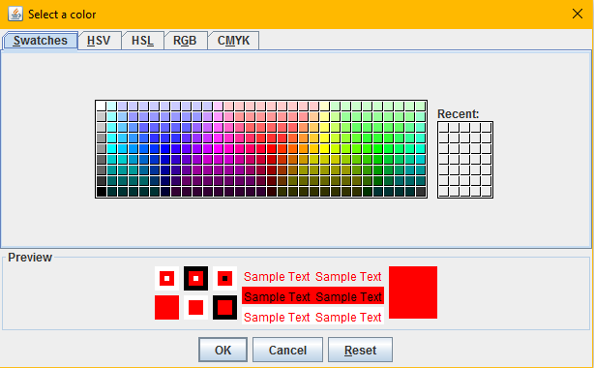

**Aim: iii) Write a Program to implement ArrayList.**

**Source Code:**

package exp3;

import java.util.*;

class arraylist

{

public static void main(String args[])

{

ArrayList list=new ArrayList();

list.add("Android");

list.add("IOS");

list.add("Windows");

list.add("Linux");

Iterator itr=list.iterator();

while(itr.hasNext())

{

System.out.println(itr.next());

}

}

}

**Output:**

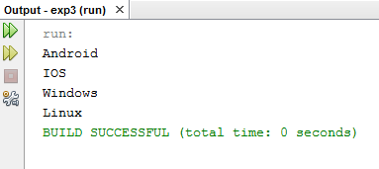

**Aim: iv) Write a Program to implement LinkedList.**

**Source Code:**

package exp3;

import java.util.*;

public class linkedlist

{

public static void main(String args[])

{

LinkedList al=new LinkedList();

al.add("Android");

al.add("IOS");

al.add("Windows");

al.add("Linux");

Iterator itr=al.iterator();

while(itr.hasNext())

{

System.out.println(itr.next());

}

}

}

**Output:**

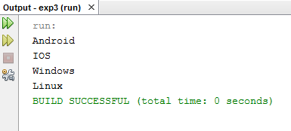

**Aim: v) Write a Program to implement Vector.**

**Source Code:**

package exp3;

import java.util.*;

class vector

{

public static void main(String args[])

{

Vector v=new Vector();

v.add("Delhi");

v.addElement("Mumbai");

v.addElement("Kolkata");

v.addElement("Banglore");

Enumeration e=v.elements();

while(e.hasMoreElements())

{

System.out.println(e.nextElement());

}

}

}

**Output:**

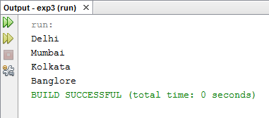

**Program Name: 9. JDBC Connectivity**

**Aim: i) Write a JDBC program to update the mobile number of student whose roll number is 23.**

**Source Code:**

package exp2;

import java.sql.*;

public class Updatedb

{

public static void main(String args[])

{

int rn;

String name;

try

{

Class.forName("com.mysql.jdbc.Driver");

Connection con = DriverManager.getConnection("jdbc:mysql://localhost:3306/student","root","harshit");

PreparedStatement pstmt=con.prepareStatement("update sinfo set mobile=94639464 where roll_no=23");

pstmt.executeUpdate();

System.out.println("mobile number updated successfully");

pstmt.close();

con.close();

}

catch(ClassNotFoundException | SQLException e)

{

System.out.println("problem with connection");

}

}

}

**Output:**

**Before:**

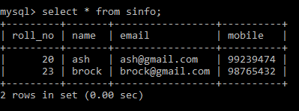

**Executing Java Program:**

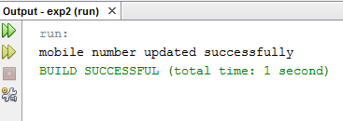

**After:**

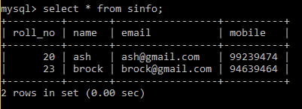

**Aim: ii) Write a JDBC program to select information of all the students from the table STUDENT.**

**Source Code:**

import java.sql.*;

public class SelectAll

{

public static void main(String args[])

{

try

{

Class.forName("com.mysql.jdbc.Driver");

Connection con = DriverManager.getConnection("jdbc:mysql://localhost:3306/university","root","harshit");

Statement s = con.createStatement();

ResultSet rs = s.executeQuery("select * from student");

while (rs.next())

{

System.out.println(rs.getInt(1)+" "+rs.getString(2)+" "+rs.getInt(3));

}

con.close();

}

catch(ClassNotFoundException | SQLException e)

{

System.out.println("problem with connection");

}

}

}

**Output:**

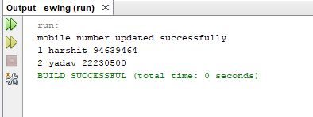

**Program Name: 10. Servlet , JSP**

**Aim: i) Write a program to print Hello Servlet using Servlet Programming.**

**Source Code:**

import java.io.*;

import javax.servlet.ServletException;

import javax.servlet.annotation.WebServlet;

import javax.servlet.http.*;

@WebServlet(urlPatterns = {"/NewServlet1"})

public class NewServlet1 extends HttpServlet

{

protected void processRequest (HttpServletRequest request, HttpServletResponse response)

throws ServletException, IOException

{

response.setContentType("text/html;charset=UTF-8");

try (PrintWriter out = response.getWriter())

{

out.println("Hello Servlet");

}

}

}

**Output:**

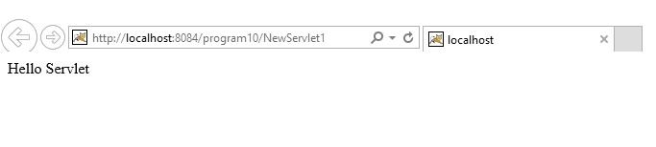

**Aim: ii) Write a program to implement the JSP Directive.**

**Source Code:**

<%@page contentType="text/html" pageEncoding="UTF-8"%>

<!DOCTYPE html>

<html>

<head>

<meta http-equiv="Content-Type" content="text/html; charset=UTF-8">

<title>JSP Page</title>

</head>

<body>

<%@ page import="java.util.Date" %>

<h1>Today is <%= new Date() %> </h1>

</body>

</html>

**Output:**

